**CHAPTER 1**

**INTRODUCTION**

The electricity sector in our present life is our lifeblood and the secret of its permanence. In some places, the agricultural sector is suffering from continuous interruptions of electricity, especially in daylight hours when farmers carry out irrigation operations on farms, causing a shortage of water to process the fields, especially for farmers who live a distance from their farms . Our goal in this research is to help these farmers by designing and manufacturing a remote-control system that runs and shuts down irrigation pumps through the use of modern technology called LoRa communication . The “RF LoRa physical layer” works as a method for modulation of the “spread spectrum”. The LoRa modulation pattern works as “wide-band linear frequency modulated pulses”. The amount of frequency growth or reduction in the above period is worked to encrypt the information being spread, i.e. a method of “chirp modulation”. This method of modulation supports LoRa structures to demodulate information that are 20dB lower than the ground noise once the demodulation is joined with “forward error correction FEC”. It can be said that the connection economical for a LoRa structure should deliver an enhancement of further than 25dB after it is related to a traditional FSK scheme .

A variation of bandwidths exists such as: “7.8 kHz; 10.4 kHz; 15.6 kHz; 20.8 kHz; 31.2 kHz; 41.7 kHz; 62.5 kHz; 125 kHz; 250 kHz; and 500 kHz”. The essential bandwidth is designated providing information necessities in addition to connection situations. The amount of power taken inside “LoRa RF physical layer” is changeable. The power amount taken by LoRa is related to the data rate required and the circumstances of the connection. A procedure calculates the essential power amount. The spread power is usually reduced slightly from the extreme required to provide rapid communications. Within that technique the battery-operated lifetime is raised. The usage of the “chirp spread spectrum” technique allows communications through miscellaneous information that is never affected by other signals.

**2.1: Block Diagram Description**

In our paper, a system was designed and implemented to monitor and control the running and switching on and off of irrigation pumps for farmers living in areas a distance from their land. The device is designed and manufactured using the latest technology in modern communications (LoRa Technology). The advantages of this technology is its small size, cheap price, and its ability to control devices remotely up to 10 km without the use of towers for communication and other additional costs. This device operates on a battery that works for more than five years and consumes a low level of power by these devices. LoRa technology devices have a range from 1 km to more than 10 km. The 2.8 km range was used in our paper. As shown in Figure 1, the types of applications that use LoRa technology



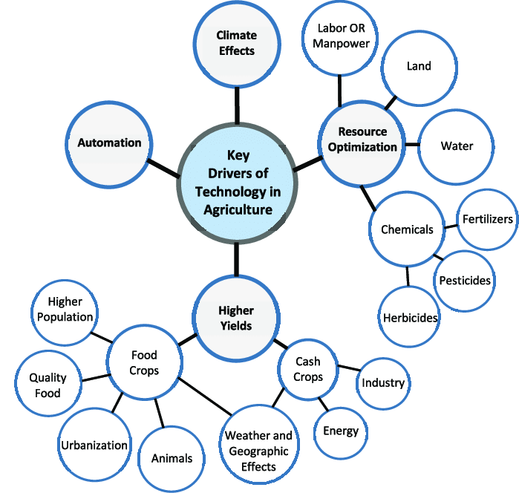

Fig. 2.1: Block Diagram of IoT based appliance control and monitoring system using LoRaWAN technology

**2.2: MAJOR APPLICATIONS**

**2.2.1: SOILSAMPLING AND MAPPING**

Soil is the stomach‖ of plants, and its sampling is the first step of examination to obtain field-specific information, which is then further used to make various critical decisions at different stages. The main objective of soil analysis is to determine the nutrient status of a field so that measures can be taken accordingly when nutrient deficiencies are found. Comprehensive soil tests are recommended on an annual basis, ideally in Spring; however, based on soil conditions and weather consents, it may be done in in Fall or Winter . The factors that are critical to analyze the soil nutrient levels include soil type, cropping history, fertilizer application, irrigation level, topography, etc. These factors give insight regarding the chemical, physical, and biological statuses of a soil to identify the limiting factors such that the crops can be dealt accordingly. Soil mapping opens the door to sowing different crop varieties in a specific field to better match soil properties accordingly, like seed suitability, time to sow, and even the planting depth, as some are deep-rooted and others less. Furthermore, growing multiple crops together could also lead to smarter use of agriculture, simply making the best use of resources be taken accordingly when nutrient deficiencies are found. Comprehensive soil tests are recommended on an annual basis, ideally in Spring; however, based on soil conditions and weather consents, it may be done in in Fall or Winter . The factors that are critical to analyze the soil nutrient levels include soil type, cropping history, fertilizer application, irrigation level, topography, etc. These factors give insight regarding the chemical, physical, and biological statuses of a soil to identify the limiting factors such that the crops can be dealt accordingly. Soil mapping opens the door to sowing different crop varieties in a specific field to better match soil properties accordingly, like seed suitability, time to sow, and even the planting depth, as some are deep-rooted and others less. Furthermore, growing multiple crops together could also lead to smarter use of agriculture, simply making the best use of resources.



Fig.2.2.1.A: Circuit Diagram of smart agriculture by using LoRa

**2.2.2: LoRaWAN Network Architecture**

The majority of LPWAN networks use the star network topology. Its nature is identified based on one central node, acts as gateway, and connects with all the other connected devices . On the other hand, the mesh network topology consists of individual nodes that propagate data to the other nodes to raise the range of communication.



Fig.2.2.2(A): LoRaWAN Architecture

The implementation of LoRaWAN network is based on the star network topology, and mostly, stars-of-stars network. The benefits of using star topology is preserving battery life and decreasing the complexity of the network meanwhile the nodes do not have to propagate or forward other nodes data, the nodes receives only its own data. Figure 2.2.2 illustrates the architecture of LoRaWAN, which can be divide into frontend and back-end parts . The front-end part contains gateway elements and the end nodes. While the back-end part contains the network servers that is responsible for checking security, storing the received information, filtering duplicate packets, and scheduling acknowledgements through the gateway .



Fig. 2.2.2(B): Circuit Diagram of basic home automation

**2.3 LORAWAN OVERVIEW:**

Wireless technologies can be classified based on their range into four ranges, Figure 2 presents the classification of wireless technologies based on their range. The first is the contact range, which is proximity and have a range of 0-to- 10 meters, like RFID technology . The second is the short range that known as wireless personal area network (WPAN) with range from 10-to-100 meters, such as Bluetooth and ZigBee technologies. The third is the short/medium range, which identified as wireless local area network (WLAN) with 100-to-1000 meters’ range, like Wi-Fi networks . Finally, the long range that is our goal and well known by wireless wide area network (WWAN) with range up to 100 km, like cellular and LPWAN. LPWAN technology is one of the most popular techniques used in WWAN networks. In more deep, LoRaWAN protocol, which based on LoRa technology, is the most common low power with long-range network that is convenient with the current and future age, the IoT era.



Fig. 2.3.1: Low Power WAN (LPWAN) Technologies

**CHAPTER 3**

**CIRCUIT DESCRIPTION**

**3.1: Microcontroller: ATmega2560**

The ATmega2560 is a low power and high performance 8-bit microcontroller, a member of AVR microcontroller family developed and produced by Atmel Corporation. By using advanced RISC architecture, the ATmega2560 can perform 135 powerful instructions in one single clock cycle. The microcontroller can be programmed with built-in flash memory 256KB, EEPROM 4KB and RAM 8KB. The ATmega2560 is provided with two package options 100-lead and 100-ball. In this project, the selected package is 100-lead TQFP (Thin Quad Flat Package)-pinout.

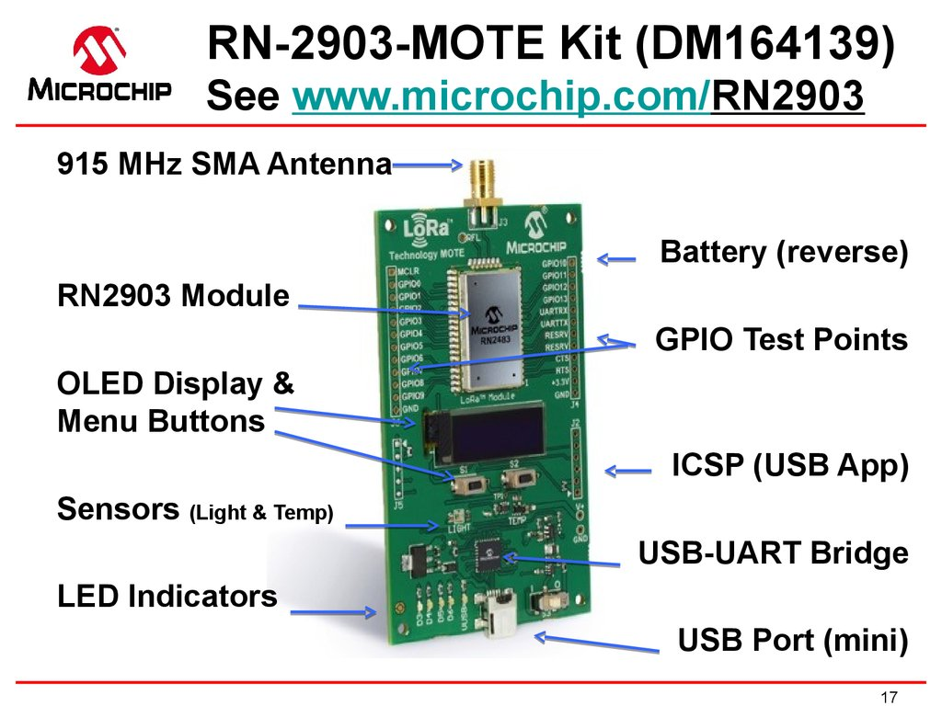

Fig.3.1: Microchip DM164139 LoRa Mote Board is certified via the LoRa Alliance

comprehensive certification program

**3.2: Pin Diagram**

The 100 pins comprise:

• 4 pins Vcc: Digital power supply pins

• 5 pins GND: Ground connection pins

86 I/O pins: General purpose input/output pins

• 1 pin RESET: Reset input pin

• 1 pin XTAL 1: Input to inverting oscillator amplifier

• 1 pin XTAL 2: Output from the oscillator amplifier

• 1 pin AVCC: Power supply for port F and AD converter

• 1 pin AREF: Analog reference pin for AD converter

The microcontroller has power supply range Vcc from 1.8V to 5.5V and operation

temperature between -40°C and 85°C. When working under condition Vcc = 2V and

oscillator frequency= 1MHz, the ATmega2560 has very low power consumption at active mode 0.5mA and idle mode 0.14mA.

The ATmega2560 is able to communicate via 3 communication peripherals: SPI (Serial Peripheral Interface), USART (Universal Synchronous and Asynchronous Receiver Transmitter) and I2C (Inter-integrated Circuit). Due to lack of USB support, the device in this project will be programmed by ISP (In System Programming) method through SPI interface. ISP is one of the best way to program an AVR microcontroller

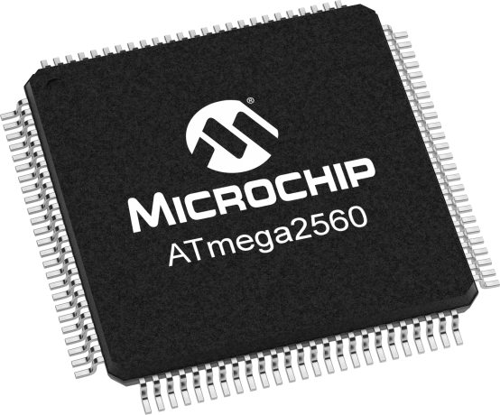

Fig.3.2: Pin Diagram

**3.3: LoRa module**

LoRa (LoRa) is a low power wide area network (LPWAN) protocol developed by semtech. It is based on spread spectrum modulation techniques derived from chirp spread spectrum (CSS) technology. LoRa module works o technology named LoRaWAN which is the communication protocol and system architecture for the network, while the LoRa physical layer enables the long-range communication link. LoRaWAN is also responsible for managing the communication frequencies, data rate, and power for all devices. Devices in the network are asynchronous and transmit when they have data available to send. Data transmitted by an end-node device is received by multiple gateways, which forward the data packets to a centralized network server. The network server filters duplicate packets, performs security checks, and manages the network. Data is the forwarded to application servers. The technology shows highly reliability for the moderate load; however, it has some performance issues related to sending acknowledgements.

LoRa uses license-free sub-gigahertz [radiofrequency](https://en.wikipedia.org/wiki/Radio_frequency) bands like 433 MHz, [868MHz (Europe)](https://en.wikipedia.org/wiki/Short-range_device#SRD860), 915 MHz ([Australia](https://en.wikipedia.org/wiki/Australia) and [North America](https://en.wikipedia.org/wiki/North_America)), 865 MHz to 867 MHz ([India](https://en.wikipedia.org/wiki/India)) and 923 MHz ([Asia](https://en.wikipedia.org/wiki/Asia)). LoRa enables long-range transmissions (more than 10 km in rural areas) with low power consumption. The technology covers the [physical layer](https://en.wikipedia.org/wiki/Physical_layer), while other technologies and protocols such as LoRaWAN (Long Range Wide Area Network) cover the upper layers. It can achieve data rate from 27 Kbps to 0.3 Kbps depending upon the spreading factor.In January 2018, new LoRa chipsets were announced, with reduced power consumption, increased transmission power, and reduced size compared to older generation. Lora devices have Geological capabilitiesused for the trilateration positions of devices via timestamps from gateways.LoRa and LoRaWAN permit long-range connectivity for [Internet of things](https://en.wikipedia.org/wiki/Internet_of_things) (IoT) devices in different types of industries.Range extenders for LoRaWAN are called LoRaX

**3.4: Voltage Sensor**

Voltage sensor is a device which is used to measure AC voltage of range upto 440 v AC. Voltage sensor consists of step-down transformer which helps to reduce voltage and Analog to Digital converter is mounted onto the board for converting Analog form to digital form by using rectifier.

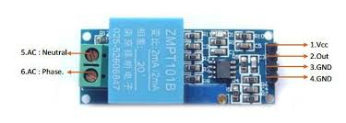

Fig.3.4: Voltage measurement using Voltage Sensor

**3.5:** **Regulator MCP1700**

Since the device is intended to operate at remote locations, it is poorly suitable for a main powered design. Instead, the intention is to use three AAA batteries which is totals a 4.5V power supply. However, some components could not tolerate the power supply 4.5V hence the regulator MCP1700 is used to maintain a steady designated output. The regulator MCP1700 is a low dropout voltage regulator. It has very low quiescent current at 16.6 µA hence it is ideally used for battery-powered device. The regulator has input voltage range between 2.3V and 6.0V, and output voltage range 1.2 to 5.0V. It operates at temperature -40°C to +125°C. [17]

**3.6: Relay**

A relay is an [electrically](https://en.wikipedia.org/wiki/Electric) operated [switch](https://en.wikipedia.org/wiki/Switch). It consists of a set of input terminals for a single or multiple control signals, and a set of operating contact terminals. The switch may have any number of contacts in multiple [contact forms](https://en.wikipedia.org/wiki/Electrical_contact#Contact_form), such as make contacts, break contacts, or combinations thereof.

Relays are used where it is necessary to control a circuit by an independent low-power signal, or where several circuits must be controlled by one signal. Relays were first used in long-distance [telegraph](https://en.wikipedia.org/wiki/Electrical_telegraph) circuits as signal repeaters: they refresh the signal coming in from one circuit by transmitting it on another circuit. Relays were used extensively in telephone exchanges and early computers to perform logical operations.

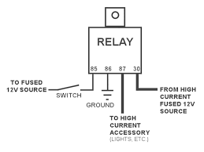

Fig.3.6: Relay

The traditional form of a relay uses an [electromagnet](https://en.wikipedia.org/wiki/Electromagnet) to close or open the contacts, but other operating principles have been invented, such as in [solid-state relays](https://en.wikipedia.org/wiki/Solid-state_relay) which use [semiconductor](https://en.wikipedia.org/wiki/Semiconductor) properties for control without relying on [moving parts](https://en.wikipedia.org/wiki/Moving_parts). Relays with calibrated operating characteristics and sometimes multiple operating coils are used to protect electrical circuits from overload or faults; in modern electric power systems these functions are performed by digital instruments still called [protective relays](https://en.wikipedia.org/wiki/Protective_relay).

Latching relays require only a single pulse of control power to operate the switch persistently. Another pulse applied to a second set of control terminals, or a pulse with opposite polarity, resets the switch, while repeated pulses of the same kind have no effects. Magnetic latching relays are useful in applications when interrupted power should not affect the circuits that the relay is controlling.

**3.7: Battery**

Batteries convert [chemical energy](https://en.wikipedia.org/wiki/Chemical_energy) directly to [electrical energy](https://en.wikipedia.org/wiki/Electrical_energy). In many cases, the electrical energy released is the difference in the cohesive or bond energies of the metals, oxides, or molecules undergoing the electrochemical reaction. For instance, energy can be stored in Zn or Li, which are high-energy metals because they are not stabilized by d-electron bonding, unlike [transition metals](https://en.wikipedia.org/wiki/Transition_metals). Batteries are designed such that the energetically favorable [redox](https://en.wikipedia.org/wiki/Redox) reaction can occur only if electrons move through the external part of the circuit.

A battery consists of some number of [voltaic cells](https://en.wikipedia.org/wiki/Voltaic_cell). Each cell consists of two [half-cells](https://en.wikipedia.org/wiki/Half-cell) connected in series by a conductive [electrolyte](https://en.wikipedia.org/wiki/Electrolyte)containing metal cations. One half-cell includes electrolyte and the negative electrode, the electrode to which [anions](https://en.wikipedia.org/wiki/Ion#Anions_and_cations) (negatively charged ions) migrate; the other half-cell includes electrolyte and the positive electrode, to which [cations](https://en.wikipedia.org/wiki/Ion#Anions_and_cations) (positively charged [ions](https://en.wikipedia.org/wiki/Ion)) migrate. Cations are reduced (electrons are added) at the cathode, while metal atoms are oxidized (electrons are removed) at the anode.[[15]](https://en.wikipedia.org/wiki/Electric_battery#cite_note-15) Some cells use different electrolytes for each half-cell; then a separator is used to prevent mixing of the electrolytes while allowing ions to flow between half-cells to complete the electrical circuit.

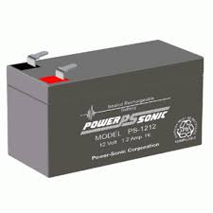

Fig.3.8: Battery

In this seminar for supplying power a 12-volt DC battery is used to supplying the power to the Arduino board and the IoT Server.

**3.8: Advantages**

1. Easy to build and deploy.
2. Less energy consumption compared to other systems.
3. Reduce human effort results a profitable output.
4. It consumes less power and hence battery will last for longer duration.
5. Very accurate detection.
6. Completely wireless system.

**3.9: Disadvantage**

1. It can be used for applications requiring low data rate i.e. upto about 27 Kbps.
2. LoRa is only suited for short and periodical communications.

**3.10: Applications**

1. Used in agriculture and industrial automation.
2. Used in medical refrigerators.
3. Used in vehicle tracking system.
4. It is also use home security.

**CHAPTER 4**

**CIRCUIT DETAILS**

The control circuit is the main circuit of the intelligent device designed in this paper, which connects directly to the input of the power supply designated for the operation of the irrigation pump. This can be divided into three sections linked to each other and constitute a total so-called control circuit:

a) Transmitter and Receiver circuit

The transmitter and receiver circuit shown in Figure 4 is the main circuit or main part of the control circuit, which consists of LoRa ESP32 wireless technology (the latest type of long-range wireless communication) with transmission and delivery ranges of more than 10 km..



Fig. 4: LoRa Communication System

In the program, first we start and establish the connection with LoRaWAN. If connection not establish, system retry to connect with LoRaWAN. After secured connection with LoRaWAN, it firstly sends all the data regarding the healthy phases, phase voltages, status of appliances, etc. when user sends command after analysing

b) The Voltage Monitoring Circuit

The second part of the control circuit is the monitoring circuit as shown in Figure 3. this device indicates if the current in the primary board can run irrigation motor or the current is cut. The main voltage, which is 230 V to 5 V, is converted by high-value resistance and there is an electrical circuit between the current of the main board and the controller circuit located within the LoRa technology.



Fig 5.Voltage mesurring circuit:

**CHAPTER 5**

**CONCLUSION**

In this paper, a smart system was designed and implemented to monitor and operate agricultural pumps on farms using a smart and modern technique, namely LoRa technology (LoRa ESP32), the latest technology in wireless communications. This technique is used to transmit long-distance signals without additional fees or the use of towers. The battery life is long because of the low consumption of electricity. The system can be controlled by Bluetooth technology using a special program installed on smart devices running on the Android system. The circuit (the manufacturing system) proved its efficiency in the work when it is applied practically inside the university laboratory Overall, the goal of the thesis project was to develop a device to monitor and collect the variables of outdoor temperature, humidity and pressure in rural areas. In order to be able to operate remotely in remote locations, the device should have a low power footprint and require low maintenance with robust protection. To achieve the desired size, the device was designed from scratch using discrete components in order to optimize the space requirement of the PCB. Since the power source of the device came from three triple A battery and the device is intended to last a few monts without maintenance, the ATmega2560 microcontroller and BME280 sensor were chosen due to their low power consumption. Additionally, an integrated LoRa module acts as a radio module which transmits the recorded data from the sensor to a cloud server via LoRa network provided by Digita.